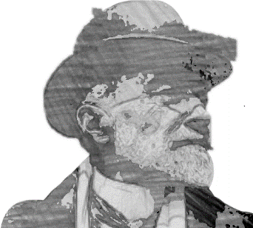
Joseph Conrad. Twixt Land and Sea
Olsztyn, 17–18 November 2017
Submission Form
Forename and surname
Academic degree / title
Affiliation
Biographical note (max. 100 words)
E-mail address
Title of the paper
Abstract (max. 150 words)
Equipment needed
Meals. Please write YES or NO below the specified dates and state if vegetarian | Lunch, 17 Nov | Banquet, 17 Nov | Lunch, 18 Nov
Other remarks
Invoice data (if applicable)

We expect your submissions by 1st September 2017.

Please send the submission form to the following e-mail address: conrad2017olsztyn@gmail.com

