COMPARATIVE SLAVIC LINGUOCULTURAL THEMES

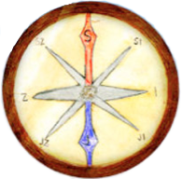 | 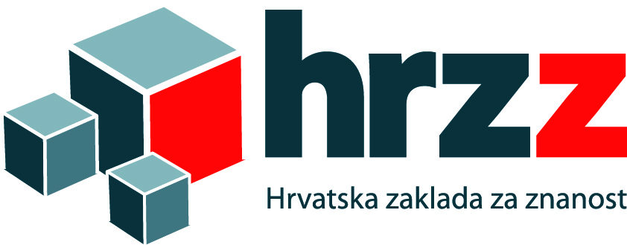

FACULTY OF HUMANITIES AND SOCIAL SCIENCES, UNIVERSITY OF ZAGREB
DEPARTMENT OF WEST SLAVIC LANGUAGES AND LITERATURES
SECTION OF POLISH LANGUAGE AND LITERATURE

First call

Esteemed colleagues,
it is an honor to invite you to the international scientific conference under the project 'Comparative Slavic Linguocultural Themes' (KOMPAS), funded by the Croatian Science Foundation (HRZZ).
The conference will be held on February 9th - 10th, 2018 (Friday and Saturday) in Zagreb. Depending on the number of participants, presentations will last between 10-15 minutes, with discussions at the end of each session.

Topics of presentations are linguistic and can be divided into following sections:
1. comparative or contrastive analysis of Slavic languages in relation to Croatian (grammatical, pragmatic, phraseological, culturological analysis);
2. Slavic language in relation to Croatian as a second and foreign language (Croatian language as a minority language in other countries, teaching Croatian to foreigners, analysis of Croatian textbooks in Croatia and other countries);
3. influence of an official language on minority languages (fieldwork data analysis, grammatical differences between Croatian as a minority language and Croatian as a national language);
4. lexicographic and lexicological challenges in Slavic studies (comparative study of the lexicon, phraseological and paremiological models);
5. Slavic etymological universals (comparative derivational models in Slavic languages).

We cordially invite you to respond to our call and to send the title of the paper and the abstract (max. 250 words) along with key words in the language of the presentation and a second language of choice no later than November 15th, 2017 to the e-mail address: ividovic@ffzg.hr .
Language of presentation: Croatian and all other Slavic languages and English.
Although we are not able to cover the costs of travel and accomodation of the participants, we will be happy to recommend affordable accomodation. More detailed information can be found on the website of the project Comparative Slavic Linguocultural Themes – http://kompas.ffzg.hr/ .

We are looking forward to your participation!

Organizing committee:
Prof. Neda Pintarić (Zagreb, Croatia) – project leader KOMPAS – npintari@ffzg.hr
Prof. Ivana Vidović Bolt (Zagreb, Croatia) – president of the Organizing committee – ividovic@ffzg.hr
Ivana Čagalj, PhD (Zagreb, Croatia) – secretary – icagalj@ffzg.hr
Miroslav Hrdlička, doctoral student (Zagreb, Croatia) – secretary – miroslavhrdlicka@yahoo.com

Program committee:
Prof. Dubravka Sesar (Zagreb, Croatia) – president of the Program committee,
Marinela Aleksovski (Zagreb, Croatia),
Prof. Zrinka Jelaska (Zagreb, Croatia),
Barbara Kovačević, PhD (Zagreb, Croatia),
Slavomira Ribarova (Zagreb, Croatia),
Asst. Prof. Anita Skelin Horvat (Zagreb, Croatia),
Prof. Joanna Szerszunowicz (Białystok, Poland),
Assoc. Prof. Oksana Timko Đitko (Zagreb, Croatia),
Prof. Branko Tošović (Graz, Austria),
Prof. Katica Trajkova (Skopje, Macedonia),
Asst. Prof. Maria Wtorkowska (Ljubljana, Slovenia)
Ana Vasung, PhD (Zagreb, Croatia)

Zagreb, August 21st, 2017

REGISTRATION FORM
International Conference
COMPARATIVE SLAVIC LINGUOCULTURAL THEMES

9th - 10th February 2018

Name and surname:
Occupation:
Phone:
E-mail:
Employment and adress of the institution:

Paper title in the language of the presentation:
Abstract and keywords in the language of the presentation (to 250 words):

Paper title in one of the official languages of the conference:
Abstract and keywords in one of the official languages of the conference (to 250 words):

Section: | 1. 2. 3. 4. 5.

